NAMES: UWIMANA Sandrine

ID: 21396

**WEB TECHNOLOGY PROJECT**

**TOPIC: NURSERY ABSENCE MANAGEMENT SYSTEM**

**General Introduction:**

Absence Management is primarily a program to control the absences due to urgency, illness, or injury with administering uninformed, unplanned or excessive absenteeism. Attendance is very important in every student, a single absent is big difference in performance in the school. Mostly it may happen that the children be absence for different reasons like illness or health condition, family emergency, and absences due to safety concerns. Some of these reasons are not reported to the teachers because the way of informing them is the traditional way which is parent need come to school and communicate with the teacher about the child’s absence. This process takes a long process and sometimes parent are not able to come because of some reasons that the parent are busy with work or they are away from the school and have an important matter to take care of.

Technologies used:

1. Eclipse
2. Spring boot web
3. My sol Driver
4. Thyme leaf

**Structure of progect:**

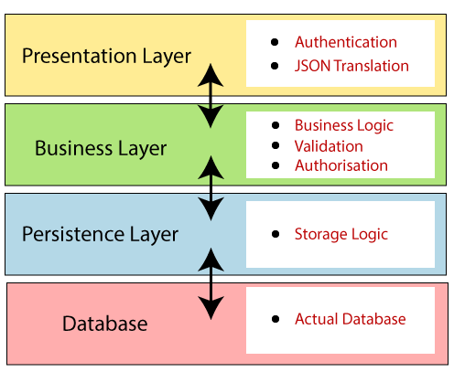

HOW TO ENTERUPT WITH NAMS:

1. Create account for new user

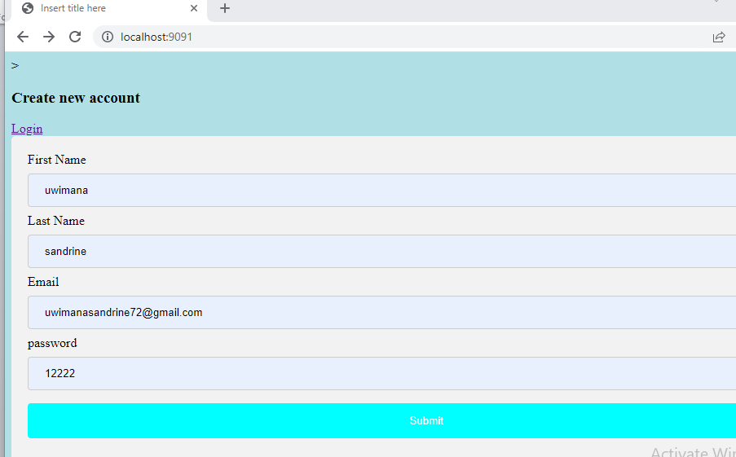

1. Login to be able to register a kid

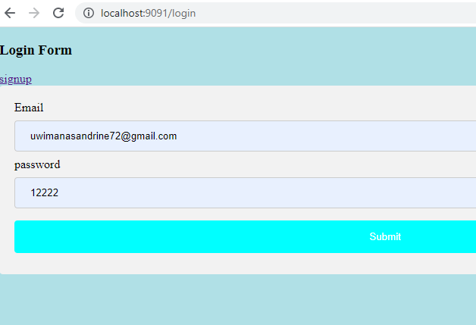

1. Add new kids

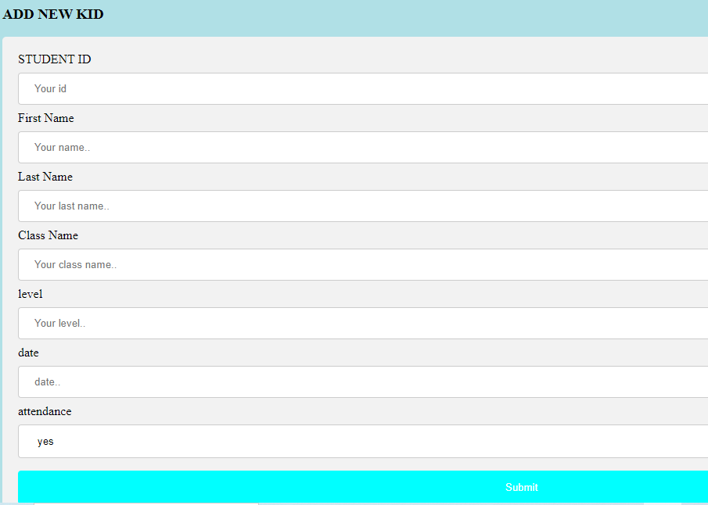

1. VIEW ALL INFORMATION ABOUT KIDS with pagnation

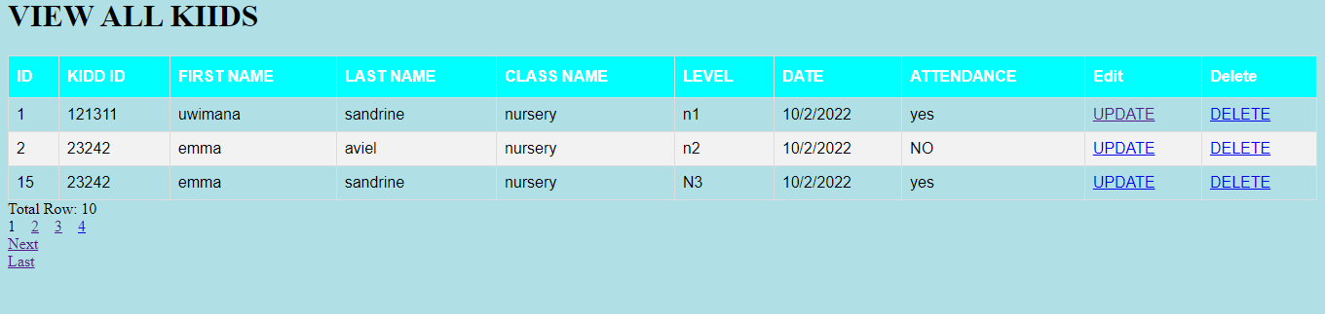

1. Update the kid’s information

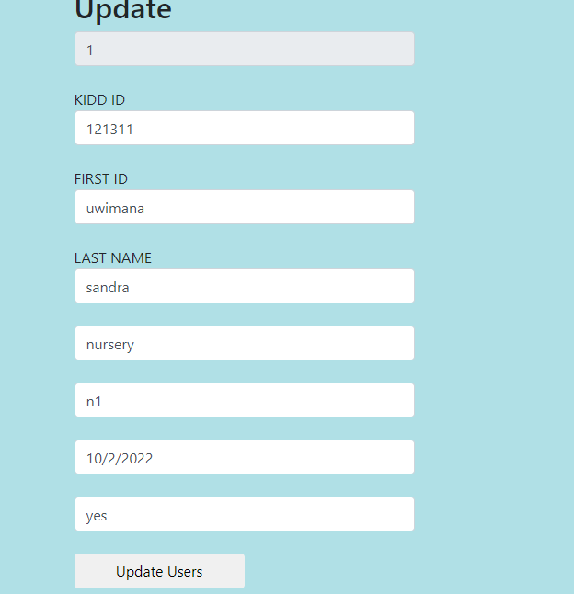

1. Deleting these information

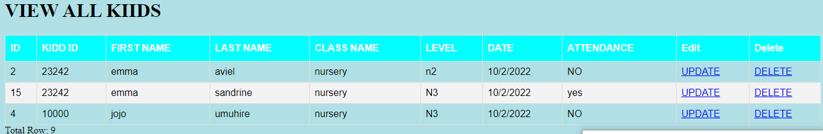

SOURCE CODE: controlers

package com.nurseryAbsence.Controllers;

import java.util.List;

import java.util.Optional;

import org.springframework.beans.factory.annotation.Autowired;

import org.springframework.data.domain.Page;

import org.springframework.stereotype.Controller;

import org.springframework.web.bind.annotation.GetMapping;

import org.springframework.web.bind.annotation.PathVariable;

import org.springframework.web.bind.annotation.PostMapping;

import org.springframework.web.bind.annotation.RequestMapping;

import org.springframework.web.bind.annotation.RequestParam;

import org.springframework.web.servlet.ModelAndView;

import com.nurseryAbsence.Models.Models;

import com.nurseryAbsence.Models.Signup;

import com.nurseryAbsence.Repos.Kidrepo;

import com.nurseryAbsence.Repos.SignupRepo;

import com.nurseryAbsence.Services.Save;

@Controller

public class Controllers {

@Autowired

private Save services;

@Autowired

private Kidrepo kidrepo;

@Autowired

private SignupRepo signupRepo;

@RequestMapping("/")

public String home() {

return "signup";

}

@RequestMapping("/login")

public String login() {

return "login";

}

@RequestMapping("/save")

public String createkid(@RequestParam("id") Integer id,@RequestParam("firstname") String firstname,@RequestParam("lastname") String lastname,@RequestParam("classname") String classname,@RequestParam("levelname") String levelname,@RequestParam("date") String date,@RequestParam("attendence") String attendence) {

Models kiddusers=new Models();

kiddusers.setStid(id);

kiddusers.setFname(firstname);

kiddusers.setLname(lastname);

kiddusers.setCname(classname);

kiddusers.setLevel(levelname);

kiddusers.setDate(date);

kiddusers.setAtendance(attendence);

services.savekid(kiddusers);

return "redirect:/view";

}

@GetMapping("/edit/{id}")

public ModelAndView showUpdateForm(@PathVariable("id") Integer id) {

Optional<Models> user = kidrepo.findById(id);

ModelAndView mav = new ModelAndView();

mav.setViewName("update");

mav.addObject("allusers",user);

return mav;

}

@RequestMapping("/view")

public ModelAndView homeafter(){

return PageShow(1);

}

@PostMapping("/update/{id}")

public String updateUser(@PathVariable("id") String id,Models user) {

Models userAttributes=new Models();

userAttributes.setId(user.getId());

userAttributes.setStid(user.getStid());

userAttributes.setFname(user.getFname());

userAttributes.setLname(user.getLname());

userAttributes.setCname(user.getCname());

userAttributes.setLevel(user.getLevel());

userAttributes.setDate(user.getDate());

userAttributes.setAtendance(user.getAtendance());

Models updatedUser = services.updateUser(userAttributes);

return "redirect:/view";

}

@GetMapping("/delete/{id}")

public String deleteUser(@PathVariable("id") Integer id) {

Models user = kidrepo.findById(id)

.orElseThrow(() -> new IllegalArgumentException("Invalid user Id:" + id));

kidrepo.delete(user);

return "redirect:/view";

}

@RequestMapping("/sign")

public String createaccount (@RequestParam("firstname") String firstname,@RequestParam("lastname") String lastname,@RequestParam("email") String email,@RequestParam("password") String password) {

Signup newaccount= new Signup();

newaccount.setFname(firstname);

newaccount.setLname(lastname);

newaccount.setEmail(email);

newaccount.setPassword(password);

services.createacccount(newaccount);

return "login";

}

@RequestMapping("/log")

public String createaccount (@RequestParam("email") String email,@RequestParam("password") String password){

Signup user = null;

try {

user= signupRepo.findByEmail(email);

}catch (Exception e) {

System.out.println(e);

}

if(user!=null && user.getEmail().equals(email)&& user.getPassword().equals(password)) {

return "addkid";

}

else {

return "login";

}

}

@GetMapping("/page/{pageNo}")

public ModelAndView PageShow(@PathVariable (value = "pageNo") int pageNo){

ModelAndView mav=new ModelAndView();

int pageSize=3;

Page<Models> page=services.getPaginated(pageNo,pageSize);

List<Models> allusersdata=page.getContent();

mav.setViewName("display");

mav.addObject("currentPage",pageNo);

mav.addObject("totalPages",page.getTotalPages());

mav.addObject("totalItems",page.getTotalElements());

mav.addObject("displayAll",allusersdata);

return mav;

}

}

MODELS:

package com.nurseryAbsence.Models;

import jakarta.persistence.Entity;

import jakarta.persistence.GeneratedValue;

import jakarta.persistence.GenerationType;

import jakarta.persistence.Id;

@Entity

public class Models {

@Id

@GeneratedValue(strategy = GenerationType.IDENTITY)

private int id;

private int stid;

private String fname;

private String lname;

private String cname;

private String level;

private String date;

private String atendance;

public int getId() {

return id;

}

public void setId(int id) {

this.id = id;

}

public int getStid() {

return stid;

}

public void setStid(int stid) {

this.stid = stid;

}

public String getFname() {

return fname;

}

public void setFname(String fname) {

this.fname = fname;

}

public String getLname() {

return lname;

}

public void setLname(String lname) {

this.lname = lname;

}

public String getCname() {

return cname;

}

public void setCname(String cname) {

this.cname = cname;

}

public String getLevel() {

return level;

}

public void setLevel(String level) {

this.level = level;

}

public String getDate() {

return date;

}

public void setDate(String date) {

this.date = date;

}

public String getAtendance() {

return atendance;

}

public void setAtendance(String atendance) {

this.atendance = atendance;

}

}

MODELS FOR SIGNUP:

package com.nurseryAbsence.Models;

import jakarta.persistence.Entity;

import jakarta.persistence.GeneratedValue;

import jakarta.persistence.GenerationType;

import jakarta.persistence.Id;

@Entity

public class Signup {

@Id

@GeneratedValue(strategy = GenerationType.IDENTITY)

private int id;

private String fname;

private String lname;

private String email;

private String password;

public int getId() {

return id;

}

public void setId(int id) {

this.id = id;

}

public String getFname() {

return fname;

}

public void setFname(String fname) {

this.fname = fname;

}

public String getLname() {

return lname;

}

public void setLname(String lname) {

this.lname = lname;

}

public String getEmail() {

return email;

}

public void setEmail(String email) {

this.email = email;

}

public String getPassword() {

return password;

}

public void setPassword(String password) {

this.password = password;

}

}

package com.nurseryAbsence.Repos;

import org.springframework.data.jpa.repository.JpaRepository;

import com.nurseryAbsence.Models.Models;

public interface Kidrepo extends JpaRepository<Models, Integer> {

}

package com.nurseryAbsence.Repos;

import org.springframework.data.jpa.repository.JpaRepository;

import com.nurseryAbsence.Models.Signup;

public interface SignupRepo extends JpaRepository<Signup, Integer> {

Signup findByEmail(String email);

}

package com.nurseryAbsence.Services;

import java.util.List;

import org.springframework.data.domain.Page;

import com.nurseryAbsence.Models.Models;

import com.nurseryAbsence.Models.Signup;

public interface Save {

public Models savekid (Models kid);

public List<Models> getALLkidds();

public Models updateUser(Models models);

public Signup createacccount (Signup account);

public Page<Models> getPaginated(int pageNo,int pageSize);

}

package com.nurseryAbsence.Services;

import java.util.List;

import org.springframework.beans.factory.annotation.Autowired;

import org.springframework.data.domain.Page;

import org.springframework.data.domain.PageRequest;

import org.springframework.stereotype.Service;

import com.nurseryAbsence.Models.Models;

import com.nurseryAbsence.Models.Signup;

import com.nurseryAbsence.Repos.Kidrepo;

import com.nurseryAbsence.Repos.SignupRepo;

@Service

public class Services implements Save{

@Autowired

private Kidrepo kidrepo;

@Autowired

private SignupRepo signupRepo;

@Override

public Models savekid(Models kid) {

return kidrepo.save(kid);

}

@Override

public List<Models> getALLkidds() {

// TODO Auto-generated method stub

return kidrepo.findAll();

}

@Override

public Models updateUser(Models models) {

// TODO Auto-generated method stub

Models existingUser = kidrepo.findById(models.getId()).get();

existingUser.setFname(models.getFname());

existingUser.setLname(models.getLname());

existingUser.setCname(models.getCname());

existingUser.setLevel(models.getLevel());

existingUser.setDate(models.getDate());

existingUser.setAtendance(models.getAtendance());

existingUser.setStid(models.getStid());

Models updatedUser = kidrepo.save(existingUser);

return updatedUser;

}

@Override

public Signup createacccount(Signup account) {

// TODO Auto-generated method stub

return signupRepo.save(account);

}

@Override

public Page<Models> getPaginated(int pageNo, int pageSize) {

PageRequest pageable= PageRequest.of(pageNo-1,pageSize);

return this.kidrepo.findAll(pageable);

}

} package com.nurseryAbsence.Services;

import java.util.List;

import org.springframework.beans.factory.annotation.Autowired;

import org.springframework.data.domain.Page;

import org.springframework.data.domain.PageRequest;

import org.springframework.stereotype.Service;

import com.nurseryAbsence.Models.Models;

import com.nurseryAbsence.Models.Signup;

import com.nurseryAbsence.Repos.Kidrepo;

import com.nurseryAbsence.Repos.SignupRepo;

@Service

public class Services implements Save{

@Autowired

private Kidrepo kidrepo;

@Autowired

private SignupRepo signupRepo;

@Override

public Models savekid(Models kid) {

return kidrepo.save(kid);

}

@Override

public List<Models> getALLkidds() {

// TODO Auto-generated method stub

return kidrepo.findAll();

}

@Override

public Models updateUser(Models models) {

// TODO Auto-generated method stub

Models existingUser = kidrepo.findById(models.getId()).get();

existingUser.setFname(models.getFname());

existingUser.setLname(models.getLname());

existingUser.setCname(models.getCname());

existingUser.setLevel(models.getLevel());

existingUser.setDate(models.getDate());

existingUser.setAtendance(models.getAtendance());

existingUser.setStid(models.getStid());

Models updatedUser = kidrepo.save(existingUser);

return updatedUser;

}

@Override

public Signup createacccount(Signup account) {

// TODO Auto-generated method stub

return signupRepo.save(account);

}

@Override

public Page<Models> getPaginated(int pageNo, int pageSize) {

PageRequest pageable= PageRequest.of(pageNo-1,pageSize);

return this.kidrepo.findAll(pageable);

}

}